The Appearance day of Nrshinga dev

A very very long time ago, there existed two evil brothers. They were known as Hiranyaksh and Hiranyakashipu. They tormented the universe and created chaos wherever they went. They overthrew the demigods and usurped them from their kingdoms. They further obtained demoniac forces to follow them and help them in conquering the heavenly planets.

The demigods were devastated and decided to go to the higher powers of the universe. They approached Lord Vishnu for help. (So here’s where it gets far out!) Vishnu took the form of a boar, by the name of Varaha, with two sharp tusks to engage battle with the demoniac brothers. But at this point in time, the two brothers were in different parts of the universe busy traumatizing living beings on different planets. So Varaha found Hiranyaksh, the younger of the brothers and pierced his chest with his sharp tusks and therefore killed him.

When Hiranyakashipu found out that Vishnu had demolished his younger brother he vowed revenge and went into meditation to obtain magical powers in order to seek out and destroy Vishnu. He stood in the jungles on one foot. And with that one foot he only used his big toe to keep himself aloft while in his meditative position. He stood in this position with a fixated mind on the creator of the universe known as Brahma. He meditated for thousands of years and the ants had already built a mound over him, eaten his flesh and reduced him to bones. Yet a fire was emanating from Hiranyakashipu’s skeleton which started to boil the cosmic oceans. The demigods had it worse now and they approached Bramha to intervene. So Brahma pitched up where Hiranyakashipu’s skeleton was and sprinkled some holy rejuvenating mana water onto the skeleton. Hiranyakashipu was instantly revived and the searing heat was quenched. Brahma asked what Hiranyakashipu wanted from him and Hiranyakashipu answered the following: “O great father to all, give me immortality!”. But Brahma could not offer such a thing as he himself was mortal. So Hiranyakashipu thought for a while and asked for the following: “O great one, give me the boon that no animal, human or weapon can destroy me. Also that I cannot be destroyed during the day or during the night. As well as not in the air and not on the ground or in water. Also not inside or outside of any place.” And so brahma granted this boon to Hiranyakashipu.

Back at Hiranyakashipu’s palace, he begot a son named Prahlad. One might think that Prahlad being the son of such an atrocious man, might be a snob and have an unwanted personality of evil traits. But Prahlad was the total opposite! He was kind in nature and gentle to all beings. He spread the love of god and the acts of humility. He preached that Vishnu (or Krishna) was the supreme personality. He meditated day in and day out on Vishnu. Of course this got him some flack with his demoniac father because his father considered himself to be the greatest supreme personality! Hiranyakashipu tried to get his son to acknowledge that he was the most supreme, but it was to no avail. Hiranyakashipu got angry and sent Prahlad to school where Sukracharya, the teacher of all the demoniac personalities, tried to teach Prahlad that his father was the most supreme. But alas, Prahlad ended up teaching the other students that Vishnu was most supreme! Sukracharya had failed.

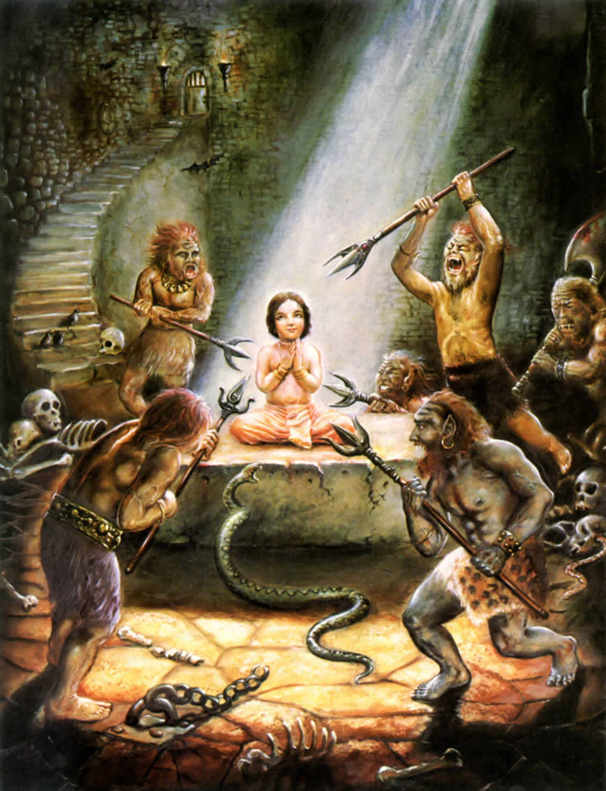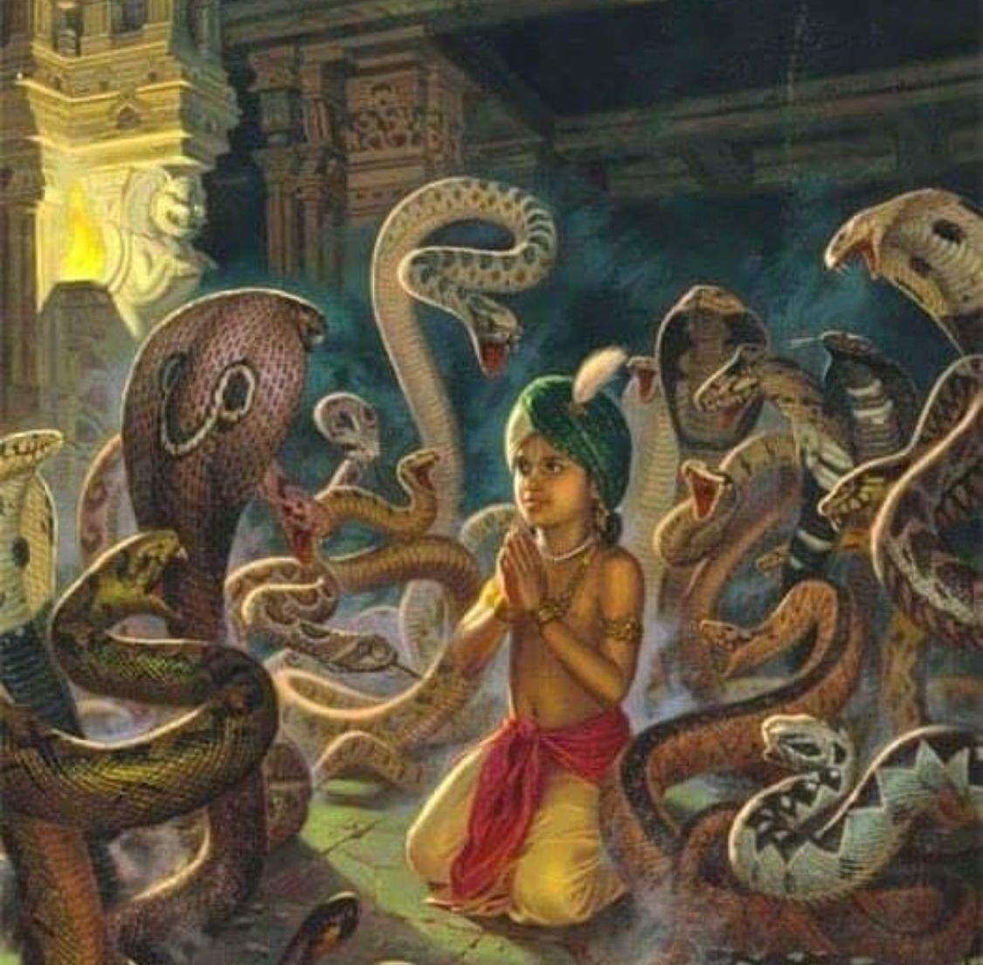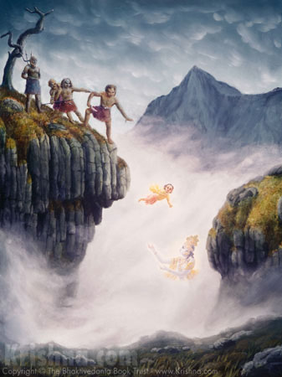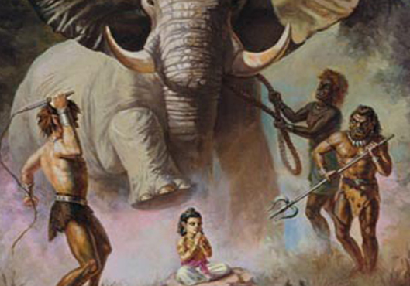

Hiranyakashipu then attempted to kill his son due to the shame he was receiving from his followers. A very evil thing indeed! He send some of his cronies to stab Prahlad with various weapons like tridents, spears and swords. But alas, when they tried, the weapons merely went through him as if he was a ghost. Prahlad was unharmed because he was protected by the Lord. His father then attempted to get a witch named Holika to burn him at the stake. She was given the boon that she could not be killed by any type of fire. She held Prahlad tight, in case he ran away. But Prahlad didn’t run away. He merely meditated. In the end as the fire raged, Holika was actually burned to death and Prahlad was unharmed. She was burned because the boon she received did not allow her to burn a devotee of the Lord. Lord Vishnu had protected him. Then Hiranyakashipu’s cronies tried to throw him off a cliff, put him in a pit of snakes, get elephants to crush him, throw him in a pot of boiling oil, but all these attempts failed. Hiranyakashipu even gave Prahlad deadly poison to drink in front of him, but Prahlad came back to life after fainting for a bit. Prahlad’s mother was in agony whilst all this was happening, but she could not go against her husband as she was a pure wife and had a pure soul.

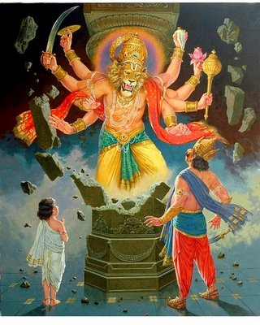

After all these attempts, Hiranyakashipu blew up in anger and asked Prahlad where he is getting his powers from. Prahlad said: “Dear father, I get my powers from the same place where you get them from, Vishnu.” At hearing Vishnu’s name, Hiranyakashipu asked his son: “Where is this Vishnu? Why is this coward hiding? Where is he?! Tell me!”, while he was shaking Prahlad. “He is everywhere father.” replied Prahlad. Now there happened to be a pillar close to where they were standing. In Hiranyakashipu’s absentmindedness he asked “Even in this pillar?” and pointed towards it. “Yes, even in there, father.” replied Prahlad. So Hiranyakashipu lifted his mace and aimed a severe blow to the pillar, not caring that the roof of the palace may have fell in on them. The pillar exploded with a tremendous ROAAAAAR. Two bright blood red eyes started emanating from the void of dust and smoke. And out came a terrible and amazing form. He was half man-half lion. He had the head of a lion and the body of a man. His fingers had sharp nails and he had a mane as bright as the sun. Anger emanated from his being. Hiranyakashipu got a fright, but started to engage this form in battle. Nrshinga dev was the name of the auspicious form of Vishnu. He was an incarnation of the form of anger which came to protect his devotee Prahlad from his father who wanted to kill him.

And so the battle waged and Hiranyakashipu tried to cast blows onto Nrshinga dev, but Nshinga dev just cast them aside as if a feather were falling on him. The battle waged for long until dusk approached. Nrshinga dev then dragged Hiranyakashipu to the doorway where he sat down and lifted Hirayakashipu onto his lap. Nrshinga dev had him wrapped up in a MMA lock so that he could not move. Just before Hiranyakashipu died, he called out to Brahma, who had given him a boon, and cried that he had been cheated and the boon did not work. Brahma appeared and told him the following “O silly demoniac being. My boons are always correct. Look at you. You are neither in water, air or land. You are on the lap of Nrshinga dev! It is also not day or night, it is dusk. You are neither inside nor outside, you are by the doorway which is neither inside nor outside. You are also not being killed by a man or animal. Nrshinga dev is neither man nor animal. Farewell!”. Nrshinga dev then tore open Hiranyakashipu’s stomach and thus killed the evil being who previously tormented the universe. The heavens were restored and the demigods threw flower petals onto Nrshinga dev and blew their conch shells out of happiness. Prahlad was instated as the next king and he ruled justly until his time was due.

The place still exists today where this all happened, Ahovilam. But beware, it is not an easy journey! Poisonous cobras and wild tigers await you. More can be found in the Shrimad Bhagavatam.